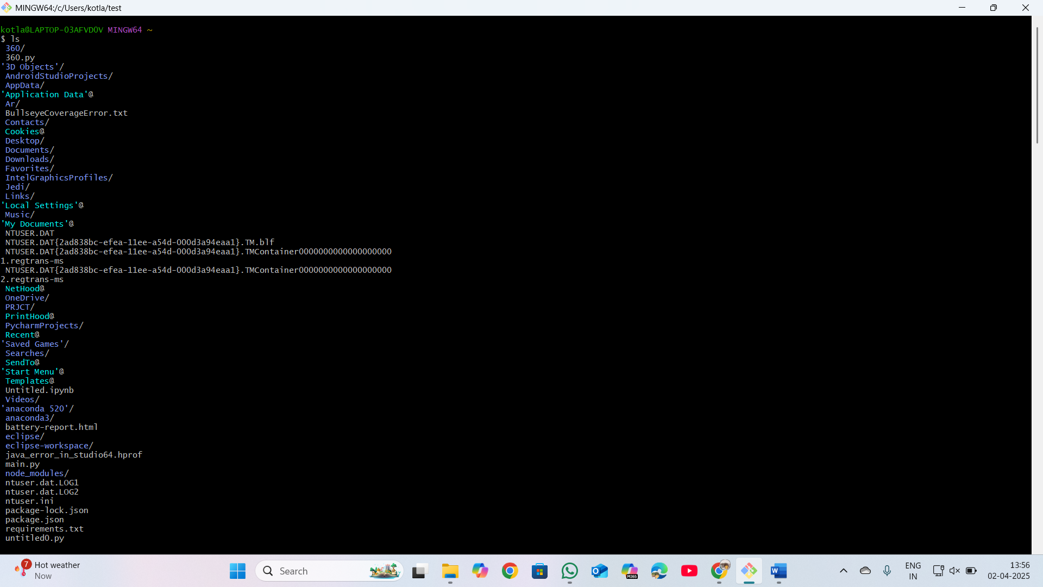

ls-lists the files and directories

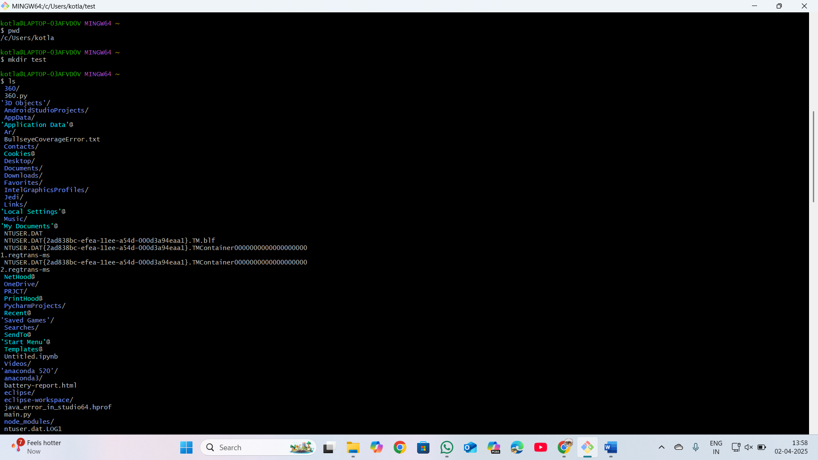

pwd-gives current working directory

mkdir-create new folder or directory

cd-change from one folder to other folder

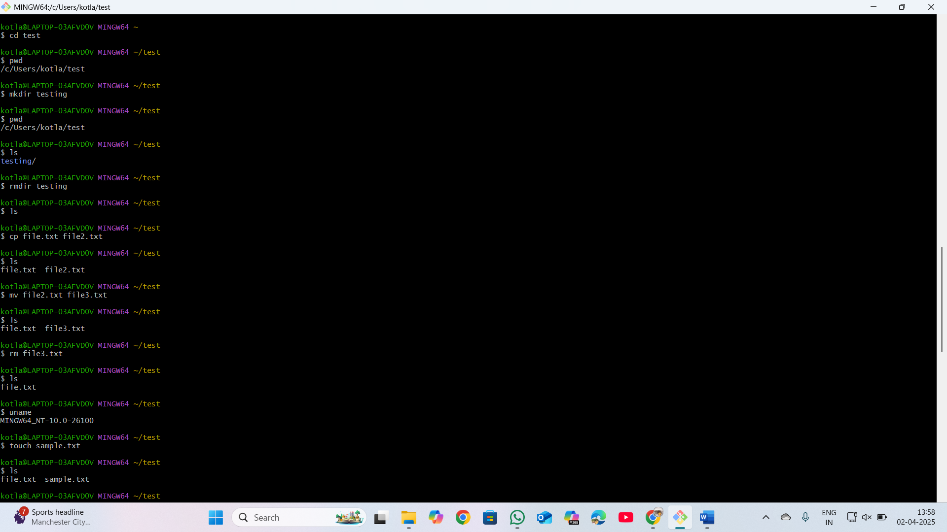

Cp-copy-paste the data from one file into other file

uname-gives OS information

Touch-gives new empty file

rmdir-remove directory

mv-rename the file name

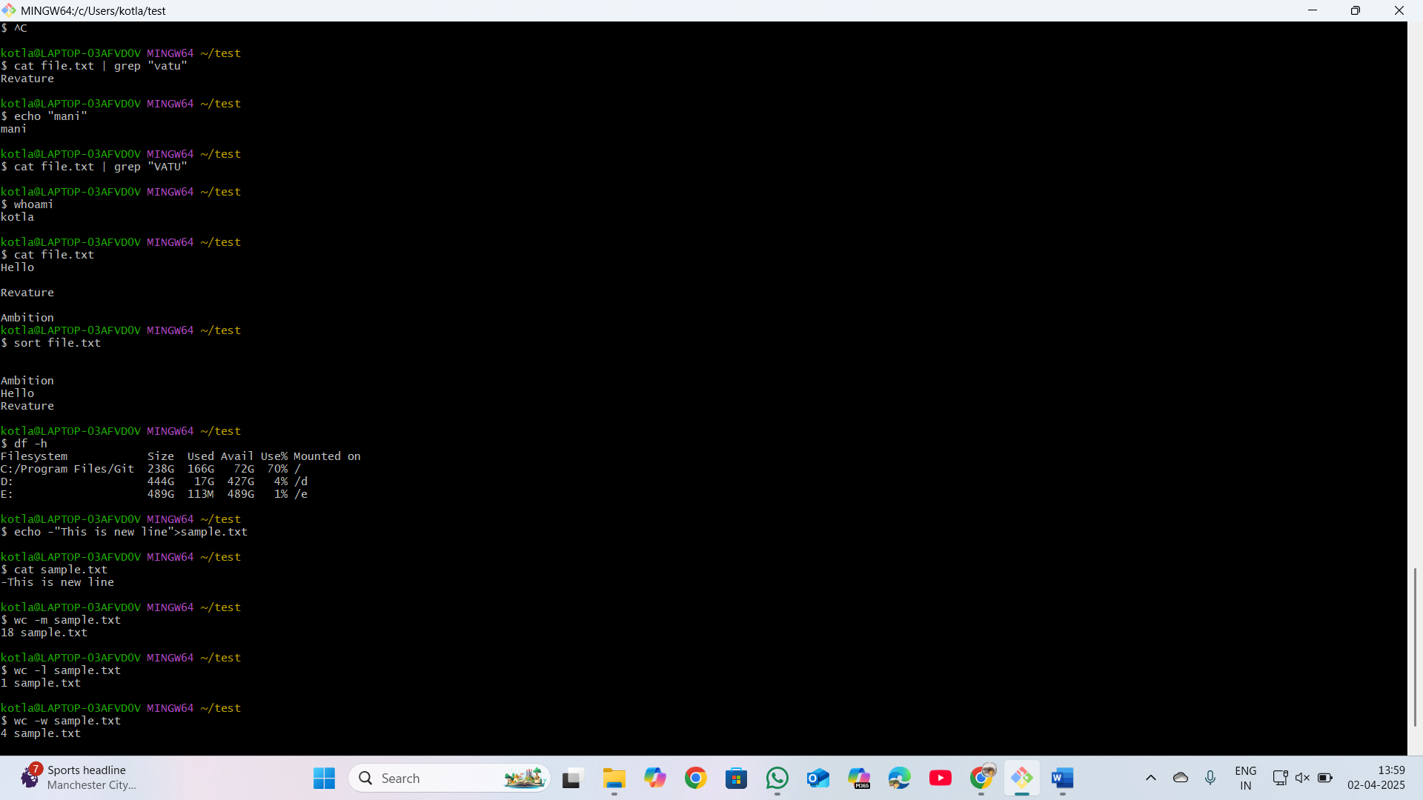

cat- displays the content inside the file

echo-just like printing the output

echo -e” ” – giving data into file through command line

grep-used to find specific string in a file

whoami-gives information about who are working

sort-generally sort the output of the file

df -h –gives details of file system

wc-w – shows number of words in a file

wc-l – shows number of lines in a file

wc-m – shows number of characters in a file